If user selects a test report which is using deleted master then the values are not shown in drop down lists,

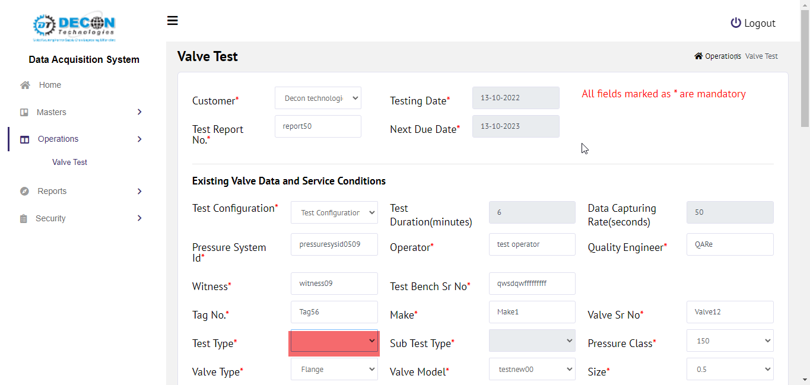

If user selects a test report which has non deleted master

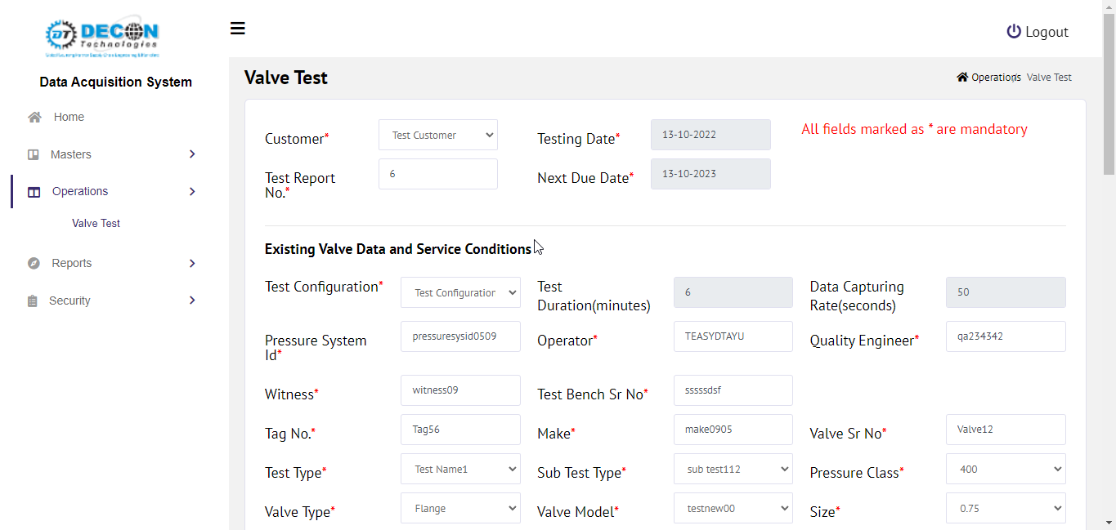

In following fields changed validations to allow zero and negative values

OpTemperature, CDTP, SetPressure, BackPressure, Range